What is Data?
Data is a collection of a distinct small unit of information. It can be used in a variety of forms like text, numbers, media, bytes, etc. it can be stored in pieces of paper or electronic memory, etc.
Word 'Data' is originated from the word 'datum' that means 'single piece of information.' It is plural of the word datum.
In computing, Data is information that can be translated into a form for efficient movement and processing. Data is interchangeable.

What is Database
The database is a collection of inter-related data which is used to retrieve, insert and delete the data efficiently. It is also used to organize the data in the form of a table, schema, views, and reports, etc. A database is an organized collection of data, so that it can be easily accessed and managed.
For example: The college Database organizes the data about the admin, staff, students and faculty etc.
Using the database, you can easily retrieve, insert, and delete the information.

Database Management System
- Database management system is a software which is used to manage the database. For example: MySQL, Oracle, etc are a very popular commercial database which is used in different applications.
- DBMS provides an interface to perform various operations like database creation, storing data in it, updating data, creating a table in the database and a lot more.
- It provides protection and security to the database. In the case of multiple users, it also maintains data consistency.
DBMS allows users the following tasks:
- Data Definition: It is used for creation, modification, and removal of definition that defines the organization of data in the database.
- Data Updation: It is used for the insertion, modification, and deletion of the actual data in the database.
- Data Retrieval: It is used to retrieve the data from the database which can be used by applications for various purposes.
- User Administration: It is used for registering and monitoring users, maintain data integrity, enforcing data security, dealing with concurrency control, monitoring performance and recovering information corrupted by unexpected failure.

Characteristics of DBMS
- It uses a digital repository established on a server to store and manage the information.
- It can provide a clear and logical view of the process that manipulates data.
- DBMS contains automatic backup and recovery procedures.
- It contains ACID properties which maintain data in a healthy state in case of failure.
- It can reduce the complex relationship between data.
- It is used to support manipulation and processing of data.
- It is used to provide security of data.
- It can view the database from different viewpoints according to the requirements of the user.

Advantages of DBMS
- Controls database redundancy: It can control data redundancy because it stores all the data in one single database file and that recorded data is placed in the database.
- Data sharing: In DBMS, the authorized users of an organization can share the data among multiple users.
- Easily Maintenance: It can be easily maintainable due to the centralized nature of the database system.
- Reduce time: It reduces development time and maintenance need.
- Backup: It provides backup and recovery subsystems which create automatic backup of data from hardware and software failures and restores the data if required.
- multiple user interface: It provides different types of user interfaces like graphical user interfaces, application program interfaces

Disadvantages of DBMS
- Cost of Hardware and Software: It requires a high speed of data processor and large memory size to run DBMS software.
- Size: It occupies a large space of disks and large memory to run them efficiently.
- Complexity: Database system creates additional complexity and requirements.
- Higher impact of failure: Failure is highly impacted the database because in most of the organization, all the data stored in a single database and if the database is damaged due to electric failure or database corruption then the data may be lost forever.

Types of Databases
There are various types of databases used for storing different varieties of data:
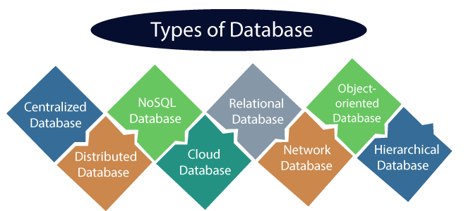

1) Centralized Database
It is the type of database that stores data at a centralized database system. It comforts the users to access the stored data from different locations through several applications. These applications contain the authentication process to let users access data securely. An example of a Centralized database can be Central Library that carries a central database of each library in a college/university.

Advantages of Centralized Database
- It has decreased the risk of data management, i.e., manipulation of data will not affect the core data.
- Data consistency is maintained as it manages data in a central repository.
- It provides better data quality, which enables organizations to establish data standards.
- It is less costly because fewer vendors are required to handle the data sets.

Disadvantages of Centralized Database
- The size of the centralized database is large, which increases the response time for fetching the data.
- It is not easy to update such an extensive database system.
- If any server failure occurs, entire data will be lost, which could be a huge loss.

2) Distributed Database
Unlike a centralized database system, in distributed systems, data is distributed among different database systems of an organization. These database systems are connected via communication links. Such links help the end-users to access the data easily. Examples of the Distributed database are Apache Cassandra, HBase, Ignite, etc.
We can further divide a distributed database system into:
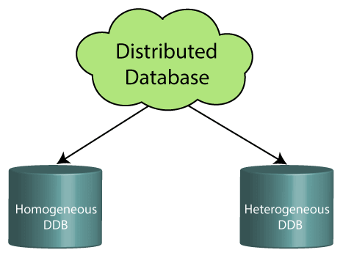
- Homogeneous DDB: Those database systems which execute on the same operating system and use the same application process and carry the same hardware devices.
- Heterogeneous DDB: Those database systems which execute on different operating systems under different application procedures, and carries different hardware devices.

Advantages of Distributed Database
- Modular development is possible in a distributed database, i.e., the system can be expanded by including new computers and connecting them to the distributed system.
- One server failure will not affect the entire data set.

3) Relational Database
This database is based on the relational data model, which stores data in the form of rows(tuple) and columns(attributes), and together forms a table(relation). A relational database uses SQL for storing, manipulating, as well as maintaining the data. E.F. Codd invented the database in 1970. Each table in the database carries a key that makes the data unique from others. Examples of Relational databases are MySQL, Microsoft SQL Server, Oracle, etc.

5) Cloud Database
A type of database where data is stored in a virtual environment and executes over the cloud computing platform. It provides users with various cloud computing services (SaaS, PaaS, IaaS, etc.) for accessing the database. There are numerous cloud platforms, but the best options are:
- Amazon Web Services(AWS)
- Microsoft Azure
- Kamatera
- PhonixNAP
- ScienceSoft
- Google Cloud SQL, etc.

6) Object-oriented Databases
The type of database that uses the object-based data model approach for storing data in the database system. The data is represented and stored as objects which are similar to the objects used in the object-oriented programming language.

7) Hierarchical Databases
It is the type of database that stores data in the form of parent-children relationship nodes. Here, it organizes data in a tree-like structure.
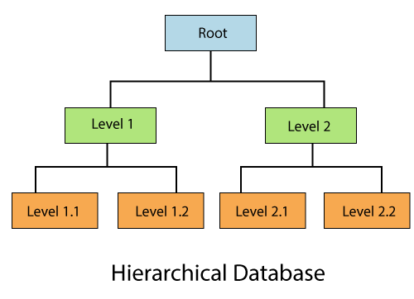
Data get stored in the form of records that are connected via links. Each child record in the tree will contain only one parent. On the other hand, each parent record can have multiple child records.

8) Network Databases
It is the database that typically follows the network data model. Here, the representation of data is in the form of nodes connected via links between them. Unlike the hierarchical database, it allows each record to have multiple children and parent nodes to form a generalized graph structure.

9) Personal Database
Collecting and storing data on the user's system defines a Personal Database. This database is basically designed for a single user.

Advantage of Personal Database
- It is simple and easy to handle.
- It occupies less storage space as it is small in size.

10) Operational Database
The type of database which creates and updates the database in real-time. It is basically designed for executing and handling the daily data operations in several businesses. For example, an organization uses operational databases for managing per day transactions.

11) Enterprise Database
Large organizations or enterprises use this database for managing a massive amount of data. It helps organizations to increase and improve their efficiency. Such a database allows simultaneous access to users.

Advantages of Enterprise Database:
- Multi processes are supportable over the Enterprise database.
- It allows executing parallel queries on the system.

What is RDBMS (Relational Database Management System)
RDBMS stands for Relational Database Management System.
All modern database management systems like SQL, MS SQL Server, IBM DB2, ORACLE, My-SQL, and Microsoft Access are based on RDBMS.
It is called Relational Database Management System (RDBMS) because it is based on the relational model introduced by E.F. Codd.

How it works
Data is represented in terms of tuples (rows) in RDBMS.
A relational database is the most commonly used database. It contains several tables, and each table has its primary key.
Due to a collection of an organized set of tables, data can be accessed easily in RDBMS.

Brief History of RDBMS
From 1970 to 1972, E.F. Codd published a paper to propose using a relational database model.
RDBMS is originally based on E.F. Codd's relational model invention.
Following are the various terminologies of RDBMS:
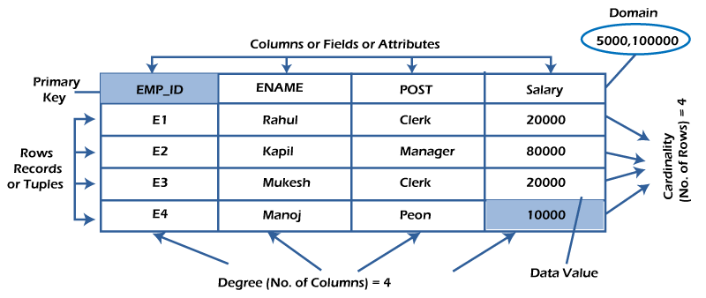

What is table/Relation?
Everything in a relational database is stored in the form of relations. The RDBMS database uses tables to store data. A table is a collection of related data entries and contains rows and columns to store data. Each table represents some real-world objects such as person, place, or event about which information is collected. The organized collection of data into a relational table is known as the logical view of the database.
Properties of a Relation:
- Each relation has a unique name by which it is identified in the database.
- Relation does not contain duplicate tuples.
- The tuples of a relation have no specific order.
- All attributes in a relation are atomic, i.e., each cell of a relation contains exactly one value.
A table is the simplest example of data stored in RDBMS.
Let's see the example of the student table.
ID | Name | AGE | COURSE
1 | Ajeet | 24 | B.Tech
2 | aryan | 20 | C.A
3 | Mahesh | 21 | BCA
4 | Ratan | 22 | MCA
5 | Vimal | 26 | BSC

What is a row or record?
A row of a table is also called a record or tuple. It contains the specific information of each entry in the table. It is a horizontal entity in the table. For example, the above table contains 5 records.
Properties of a row:
- No two tuples are identical to each other in all their entries.
- All tuples of the relation have the same format and the same number of entries.
- The order of the tuple is irrelevant. They are identified by their content, not by their position.
Let's see one record/row in the table.
ID | Name | AGE | COURSE
1 | Ajeet | 24 | B.Tech

What is a column/attribute?
A column is a vertical entity in the table which contains all information associated with a specific field in a table. For example, "name" is a column in the above table which contains all information about a student's name.

Properties of an Attribute:
- Every attribute of a relation must have a name.
- Null values are permitted for the attributes.
- Default values can be specified for an attribute automatically inserted if no other value is specified for an attribute.
- Attributes that uniquely identify each tuple of a relation are the primary key.
Name
Ajeet
Aryan
Mahesh
Ratan
Vimal

What is data item/Cells?
The smallest unit of data in the table is the individual data item. It is stored at the intersection of tuples and attributes.
Properties of data items:
- Data items are atomic.
- The data items for an attribute should be drawn from the same domain.
In the below example, the data item in the student table consists of Ajeet, 24 and Btech, etc.
ID | Name | AGE | COURSE
1 | Ajeet | 24 | B.Tech

Degree:
The total number of attributes that comprise a relation is known as the degree of the table.
For example, the student table has 4 attributes, and its degree is 4.
ID | Name | AGE | COURSE
1 | Ajeet | 24 | B.Tech
2 | aryan | 20 | C.A
3 | Mahesh | 21 | BCA
4 | Ratan | 22 | MCA
5 | Vimal | 26 | BSC

Cardinality:
The total number of tuples at any one time in a relation is known as the table's cardinality. The relation whose cardinality is 0 is called an empty table.
For example, the student table has 5 rows, and its cardinality is 5.
ID | Name | AGE | COURSE
1 | Ajeet | 24 | B.Tech
2 | aryan | 20 | C.A
3 | Mahesh | 21 | BCA
4 | Ratan | 22 | MCA
5 | Vimal | 26 | BSC

Domain:
The domain refers to the possible values each attribute can contain. It can be specified using standard data types such as integers, floating numbers, etc. For example, an attribute entitled Marital Status may be limited to married or unmarried values.

NULL Values
The NULL value of the table specifies that the field has been left blank during record creation. It is different from the value filled with zero or a field that contains space.

Data Integrity
There are the following categories of data integrity exist with each RDBMS:
Entity integrity: It specifies that there should be no duplicate rows in a table.
Domain integrity: It enforces valid entries for a given column by restricting the type, the format, or the range of values.
Referential integrity specifies that rows cannot be deleted, which are used by other records.
User-defined integrity: It enforces some specific business rules defined by users. These rules are different from the entity, domain, or referential integrity.

Difference between DBMS and RDBMS
Although DBMS and RDBMS both are used to store information in physical database but there are some remarkable differences between them.
The main differences between DBMS and RDBMS are given below:
No. | DBMS | RDBMS
1) | DBMS applications store data as file. | RDBMS applications store data in a tabular form.
2) | In DBMS, data is generally stored in either a hierarchical form or a navigational form. | In RDBMS, the tables have an identifier called primary key and the data values are stored in the form of tables.
3) | Normalization is not present in DBMS. | Normalization is present in RDBMS.
4) | DBMS does not apply any security with regards to data manipulation. | RDBMS defines the integrity constraint for the purpose of ACID (Atomocity, Consistency, Isolation and Durability) property.
5) | DBMS uses file system to store data, so there will be no relation between the tables. | in RDBMS, data values are stored in the form of tables, so a relationship between these data values will be stored in the form of a table as well.
6) | DBMS has to provide some uniform methods to access the stored information. | RDBMS system supports a tabular structure of the data and a relationship between them to access the stored information.
7) | DBMS does not support distributed database. | RDBMS supports distributed database.
8) | DBMS is meant to be for small organization and deal with small data. it supports single user. | RDBMS is designed to handle large amount of data. it supports multiple users.
9) | Examples of DBMS are file systems, xml etc. | Example of RDBMS are mysql, postgre, sql server, oracle etc.
After observing the differences between DBMS and RDBMS, you can say that RDBMS is an extension of DBMS. There are many software products in the market today who are compatible for both DBMS and RDBMS. Means today a RDBMS application is DBMS application and vice-versa.
Paradigm Shift from File System to DBMS
File System manages data using files on a hard disk. Users are allowed to create, delete, and update the files according to their requirements. Let us consider the example of file-based University Management System. Data of students is available to their respective Departments, Academics Section, Result Section, Accounts Section, Hostel Office, etc. Some of the data is common for all sections like Roll No, Name, Father Name, Address, and Phone number of students but some data is available to a particular section only like Hostel allotment number which is a part of the hostel office. Let us discuss the issues with this system:
- Redundancy of data: Data is said to be redundant if the same data is copied at many places. If a student wants to change their Phone number, he or has to get it updated in various sections. Similarly, old records must be deleted from all sections representing that student.
- Inconsistency of Data: Data is said to be inconsistent if multiple copies of the same data do not match each other. If the Phone number is different in Accounts Section and Academics Section, it will be inconsistent. Inconsistency may be because of typing errors or not updating all copies of the same data.
- Difficult Data Access: A user should know the exact location of the file to access data, so the process is very cumbersome and tedious. If the user wants to search the student hostel allotment number of a student from 10000 unsorted students’ records, how difficult it can be.
- Unauthorized Access: File Systems may lead to unauthorized access to data. If a student gets access to a file having his marks, he can change it in an unauthorized way.
- No Concurrent Access: The access of the same data by multiple users at the same time is known as concurrency. The file system does not allow concurrency as data can be accessed by only one user at a time.
- No Backup and Recovery: The file system does not incorporate any backup and recovery of data if a file is lost or corrupted.
These are the main reasons which made a shift from file system to DBMS.

DBMS Architecture
- The DBMS design depends upon its architecture. The basic client/server architecture is used to deal with a large number of PCs, web servers, database servers and other components that are connected with networks.
- The client/server architecture consists of many PCs and a workstation which are connected via the network.
- DBMS architecture depends upon how users are connected to the database to get their request done.

Types of DBMS Architecture
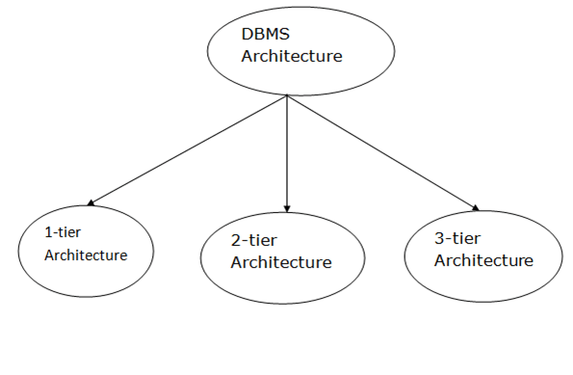
Database architecture can be seen as a single tier or multi-tier. But logically, database architecture is of two types like: 2-tier architecture and 3-tier architecture.

1-Tier Architecture
- In this architecture, the database is directly available to the user. It means the user can directly sit on the DBMS and uses it.
- Any changes done here will directly be done on the database itself. It doesn't provide a handy tool for end users.
- The 1-Tier architecture is used for development of the local application, where programmers can directly communicate with the database for the quick response.

2-Tier Architecture
- The 2-Tier architecture is same as basic client-server. In the two-tier architecture, applications on the client end can directly communicate with the database at the server side. For this interaction, API's like: ODBC, JDBC are used.
- The user interfaces and application programs are run on the client-side.
- The server side is responsible to provide the functionalities like: query processing and transaction management.
- To communicate with the DBMS, client-side application establishes a connection with the server side.
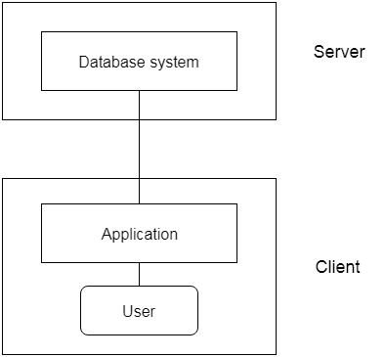
Fig: 2-tier Architecture

3-Tier Architecture
- The 3-Tier architecture contains another layer between the client and server. In this architecture, client can't directly communicate with the server.
- The application on the client-end interacts with an application server which further communicates with the database system.
- End user has no idea about the existence of the database beyond the application server. The database also has no idea about any other user beyond the application.
- The 3-Tier architecture is used in case of large web application.
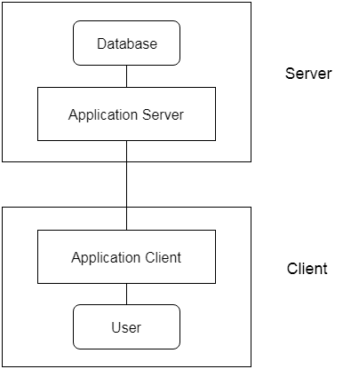
Fig: 3-tier Architecture
DBMS 3-tier Architecture
DBMS 3-tier architecture divides the complete system into three inter-related but independent modules as shown below:
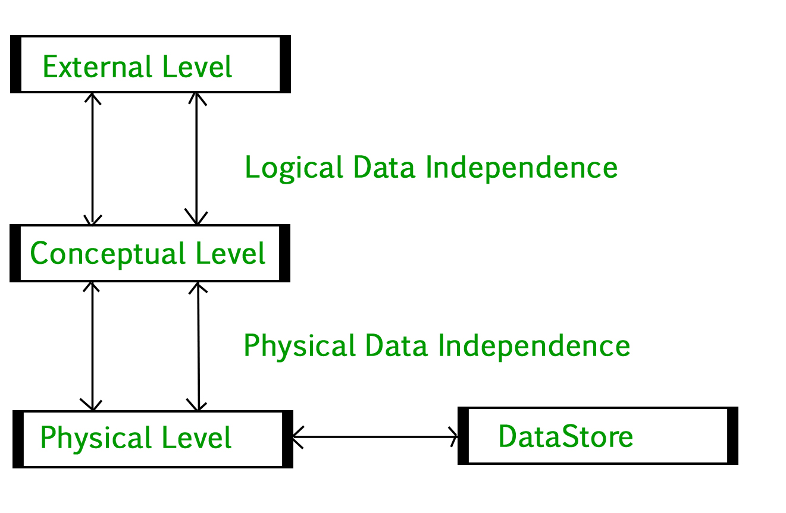
- Physical Level: At the physical level, the information about the location of database objects in the data store is kept. Various users of DBMS are unaware of the locations of these objects. In simple terms, physical level of a database describes how the data is being stored in secondary storage devices like disks and tapes and also gives insights on additional storage details.
- Conceptual Level: At conceptual level, data is represented in the form of various database tables. For Example, STUDENT database may contain STUDENT and COURSE tables which will be visible to users but users are unaware of their storage. Also referred as logical schema, it describes what kind of data is to be stored in the database.
- External Level: An external level specifies a view of the data in terms of conceptual level tables. Each external level view is used to cater to the needs of a particular category of users. For Example, FACULTY of a university is interested in looking course details of students, STUDENTS are interested in looking at all details related to academics, accounts, courses and hostel details as well. So, different views can be generated for different users. The main focus of external level is data abstraction.
Data Independence
Data independence means a change of data at one level should not affect another level. Two types of data independence are present in this architecture:
- Physical Data Independence: Any change in the physical location of tables and indexes should not affect the conceptual level or external view of data. This data independence is easy to achieve and implemented by most of the DBMS.
- Conceptual Data Independence: The data at conceptual level schema and external level schema must be independent. This means a change in conceptual schema should not affect external schema. e.g.; Adding or deleting attributes of a table should not affect the user’s view of the table. But this type of independence is difficult to achieve as compared to physical data independence because the changes in conceptual schema are reflected in the user’s view.
Phases of database design
Database designing for a real-world application starts from capturing the requirements to physical implementation using DBMS software which consists of following steps shown below:
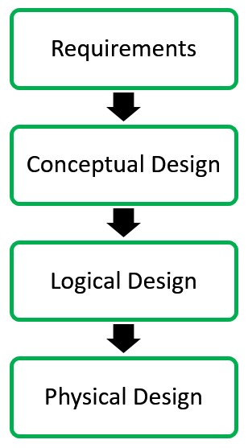
Conceptual Design: The requirements of database are captured using high level conceptual data model. For Example, the ER model is used for the conceptual design of the database.
Logical Design: Logical Design represents data in the form of relational model. ER diagram produced in the conceptual design phase is used to convert the data into the Relational Model.
Physical Design: In physical design, data in relational model is implemented using commercial DBMS like Oracle, DB2.

What is Data Dictionary
A data dictionary contains metadata i.e. data about the database. The data dictionary is very important as it contains information such as what is in the database, who is allowed to access it, where is the database physically stored etc. The users of the database normally don't interact with the data dictionary; it is only handled by the database administrators.
The data dictionary in general contains information about the following −
- Names of all the database tables and their schemas.
- Details about all the tables in the database, such as their owners, their security constraints, when they were created etc.
- Physical information about the tables such as where they are stored and how.
- Table constraints such as primary key attributes, foreign key information etc.
- Information about the database views that are visible.
This is a data dictionary describing a table that contains employee details.

Field Name | Data Type | Field Size for display | Description | Example
Employee Number | Integer | 10 | Unique ID of each employee | 1645000001
Name | Text | 20 | Name of the employee | David Heston
Date of Birth | Date/Time | 10 | DOB of Employee | 08/03/1995
Phone Number | Integer | 10 | Phone number of employee | 6583648648

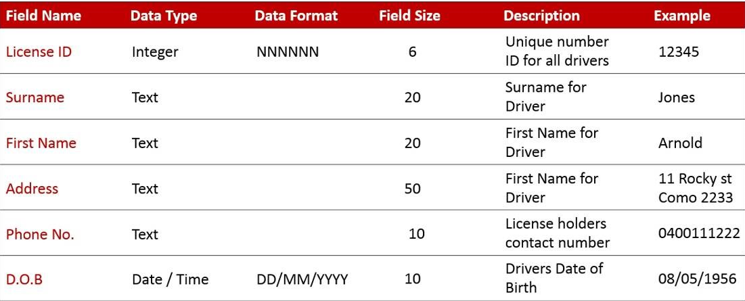

DBMS Database Models
A Database model defines the logical design and structure of a database and defines how data will be stored, accessed and updated in a database management system. While the Relational Model is the most widely used database model, there are other models too:
- Hierarchical Model
- Network Model
- Entity-relationship Model
- Relational Model

Hierarchical Model
This database model organises data into a tree-like-structure, with a single root, to which all the other data is linked. The hierarchy starts from the Root data, and expands like a tree, adding child nodes to the parent nodes.
In this model, a child node will only have a single parent node.
This model efficiently describes many real-world relationships like index of a book, recipes etc.
In hierarchical model, data is organised into tree-like structure with one one-to-many relationship between two different types of data, for example, one department can have many courses, many professors and of-course many students.
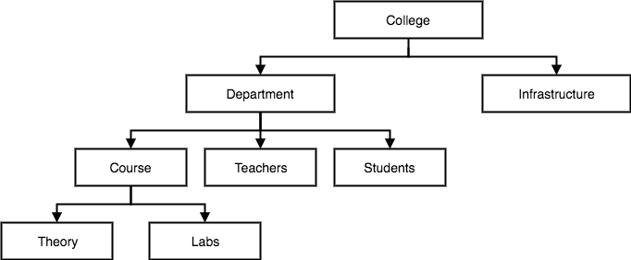

Network Model
This is an extension of the Hierarchical model. In this model data is organised more like a graph, and are allowed to have more than one parent node.
In this database model data is more related as more relationships are established in this database model. Also, as the data is more related, hence accessing the data is also easier and fast. This database model was used to map many-to-many data relationships.
This was the most widely used database model, before Relational Model was introduced.
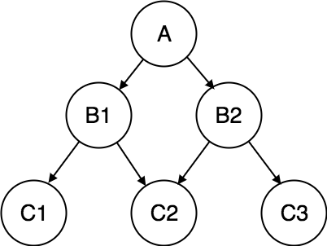

Entity-relationship Model
In this database model, relationships are created by dividing object of interest into entity and its characteristics into attributes.
Different entities are related using relationships.
E-R Models are defined to represent the relationships into pictorial form to make it easier for different stakeholders to understand.
This model is good to design a database, which can then be turned into tables in relational model (explained below).
Let's take an example, if we have to design a School Database, then Student will be an entity with attributes name, age, address etc. As Address is generally complex, it can be another entity with attributes street name, pin code, city etc., and there will be a relationship between them.
Relationships can also be of different types.
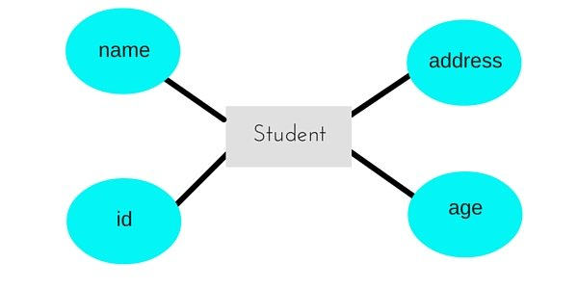

Relational Model
In this model, data is organised in two-dimensional tables and the relationship is maintained by storing a common field.
This model was introduced by E.F Codd in 1970, and since then it has been the most widely used database model, infact, we can say the only database model used around the world.
The basic structure of data in the relational model is tables. All the information related to a particular type is stored in rows of that table.
Hence, tables are also known as relations in relational model.
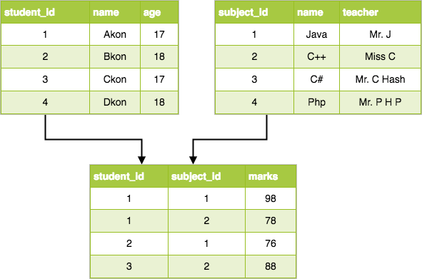

Basic Concepts of ER Model in DBMS
As we described in the tutorial Database models, Entity-relationship model is a model used for design and representation of relationships between data.
The main data objects are termed as Entities, with their details defined as attributes, some of these attributes are important and are used to identify the entity, and different entities are related using relationships.
In short, to understand about the ER Model, we must understand about:
- Entity and Entity Set
- What are Attributes? And Types of Attributes.
- Keys
- Relationships
Let's take an example to explain everything. For a School Management Software, we will have to store Student information, Teacher information, Classes, Subjects taught in each class etc.

ER Model: Entity and Entity Set
Considering the above example, Student is an entity, Teacher is an entity, similarly, Class, Subject etc. are also entities.
An Entity is generally a real-world object which has characteristics and holds relationships in a DBMS.
If a Student is an Entity, then the complete dataset of all the students will be the Entity Set.

ER Model: Attributes
If a Student is an Entity, then student's roll no., student's name, student's age, student's gender etc. will be its attributes.
An attribute can be of many types, here are different types of attributes defined in ER database model:
- Simple attribute: The attributes with values that are atomic and cannot be broken down further are simple attributes. For example, student's age.
- Composite attribute: A composite attribute is made up of more than one simple attribute. For example, student's address will contain, house no., street name, pin code etc.
- Derived attribute: These are the attributes which are not present in the whole database management system, but are derived using other attributes. For example, average age of students in a class.
- Single-valued attribute: As the name suggests, they have a single value.
- Multi-valued attribute: And, they can have multiple values.

ER Model: Keys
If the attribute roll no. can uniquely identify a student entity, amongst all the students, then the attribute roll no. will be said to be a key.
Following are the types of Keys:
- Super Key
- Candidate Key
- Primary Key

ER Model: Relationships
When an Entity is related to another Entity, they are said to have a relationship. For example, A Class Entity is related to Student entity, because students study in classes, hence this is a relationship.
Depending upon the number of entities involved, a degree is assigned to relationships.
For example, if 2 entities are involved, it is said to be Binary relationship, if 3 entities are involved, it is said to be Ternary relationship, and so on.
In the next tutorial, we will learn how to create ER diagrams and design databases using ER diagrams.

Working with ER Diagrams
ER Diagram is a visual representation of data that describes how data is related to each other. In ER Model, we disintegrate data into entities, attributes and setup relationships between entities, all this can be represented visually using the ER diagram.
For example, in the below diagram, anyone can see and understand what the diagram wants to convey: Developer develops a website, whereas a Visitor visits a website.
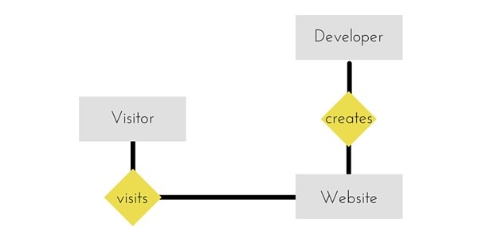

Components of ER Diagram
Entity, Attributes, Relationships etc. form the components of ER Diagram and there are defined symbols and shapes to represent each one of them.
Let's see how we can represent these in our ER Diagram.

Entity
Simple rectangular box represents an Entity.
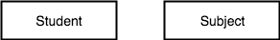

Relationships between Entities - Weak and Strong
Rhombus is used to setup relationships between two or more entities.
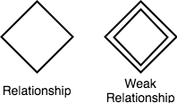

Attributes for any Entity
Ellipse is used to represent attributes of any entity. It is connected to the entity.
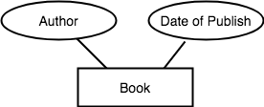

Weak Entity
A weak Entity is represented using double rectangular boxes. It is generally connected to another entity.
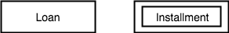

Key Attribute for any Entity
To represent a Key attribute, the attribute name inside the Ellipse is underlined.
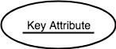

Derived Attribute for any Entity
Derived attributes are those which are derived based on other attributes, for example, age can be derived from date of birth.
To represent a derived attribute, another dotted ellipse is created inside the main ellipse.
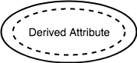

Multivalued Attribute for any Entity
Double Ellipse, one inside another, represents the attribute which can have multiple values.
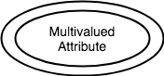

Composite Attribute for any Entity
A composite attribute is the attribute, which also has attributes.
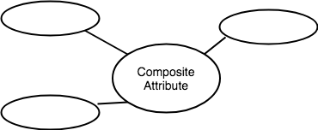

ER Diagram: Entity
An Entity can be any object, place, person or class. In ER Diagram, an entity is represented using rectangles. Consider an example of an Organisation- Employee, Manager, Department, Product and many more can be taken as entities in an Organisation.
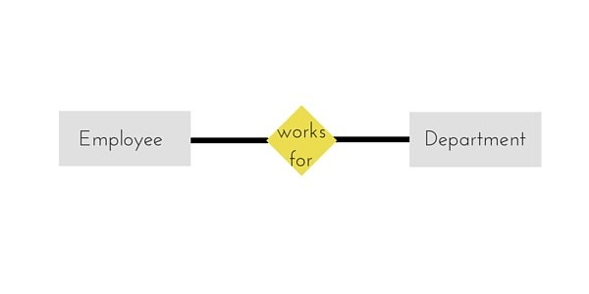
The yellow rhombus in between represents a relationship.

ER Diagram: Weak Entity
Weak entity is an entity that depends on another entity. Weak entity doesn't have any key attribute of its own. Double rectangle is used to represent a weak entity.
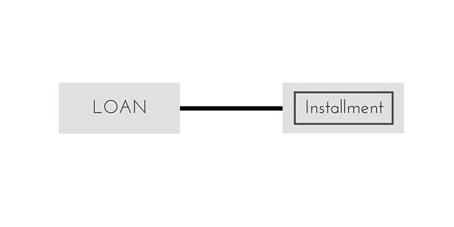

ER Diagram: Attribute
An Attribute describes a property or characteristic of an entity. For example, Name, Age, Address etc. can be attributes of a Student. An attribute is represented using eclipse.

ER Diagram: Key Attribute
Key attribute represents the main characteristic of an Entity. It is used to represent a Primary key. Ellipse with the text underlined, represents Key Attribute.
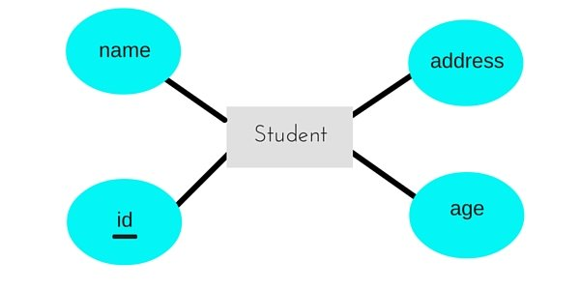

ER Diagram: Composite Attribute
An attribute can also have their own attributes. These attributes are known as Composite attributes.
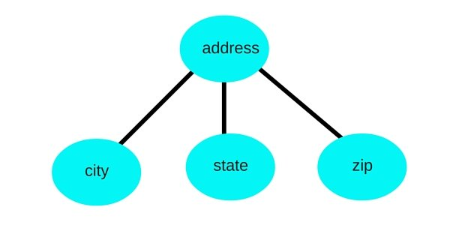

ER Diagram: Relationship
A Relationship describes relation between entities. Relationship is represented using diamonds or rhombus.
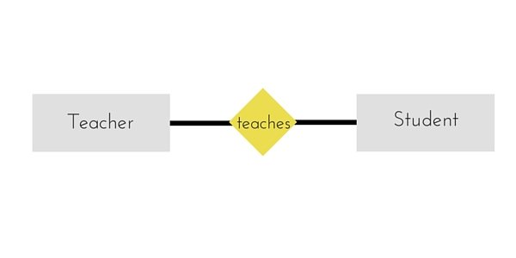
There are three types of relationship that exist between Entities.
- Binary Relationship
- Recursive Relationship
- Ternary Relationship

ER Diagram: Binary Relationship
Binary Relationship means relation between two Entities. This is further divided into three types.

One to One Relationship
This type of relationship is rarely seen in real world.
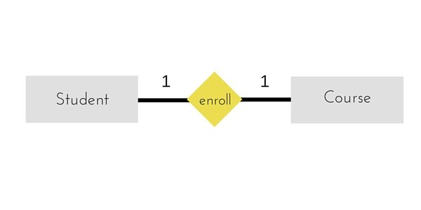
The above example describes that one student can enrol only for one course and a course will also have only one Student. This is not what you will usually see in real-world relationships.

One to Many Relationship
The below example showcases this relationship, which means that 1 student can opt for many courses, but a course can only have 1 student. Sounds weird! This is how it is.
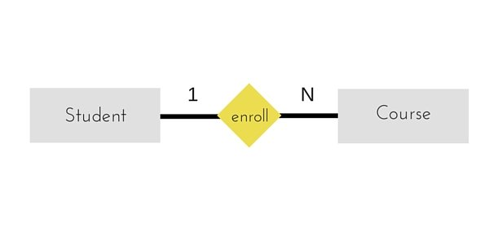

Many to One Relationship
It reflects business rule that many entities can be associated with just one entity. For example, Student enrols for only one Course but a Course can have many Students.
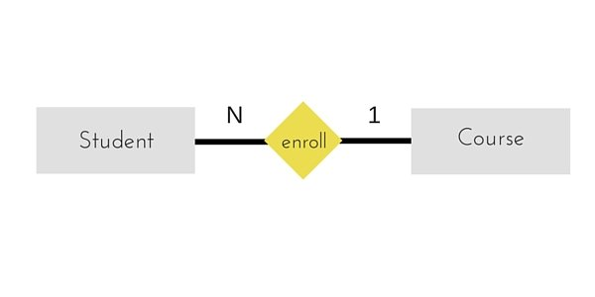

Many to Many Relationship
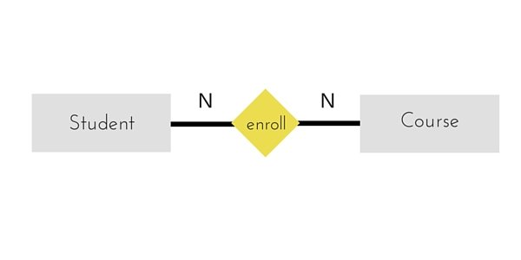
The above diagram represents that one student can enrol for more than one courses. And a course can have more than 1 student enrolled in it.

ER Diagram: Recursive Relationship
When an Entity is related with itself it is known as Recursive Relationship.
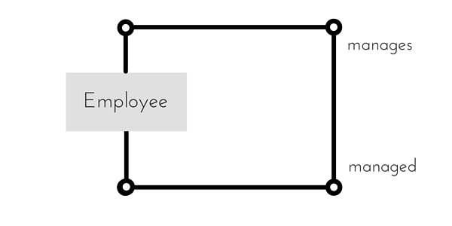

ER Diagram: Ternary Relationship
Relationship of degree three is called Ternary relationship.
A Ternary relationship involves three entities. In such relationships we always consider two entities together and then look upon the third.
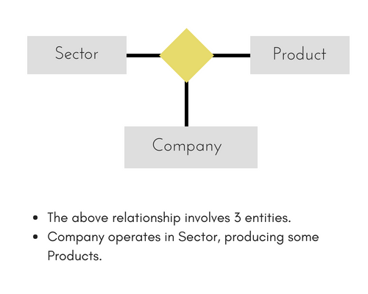
For example, in the diagram above, we have three related entities, Company, Product and Sector. To understand the relationship better or to define rules around the model, we should relate two entities and then derive the third one.
A Company produces many Products/ each product is produced by exactly one company.
A Company operates in only one Sector / each sector has many companies operating in it.
Considering the above two rules or relationships, we see that although the complete relationship involves three entities, but we are looking at two entities at a time.

The Enhanced ER Model
As the complexity of data increased in the late 1980s, it became more and more difficult to use the traditional ER Model for database modelling. Hence some improvements or enhancements were made to the existing ER Model to make it able to handle the complex applications better.
Hence, as part of the Enhanced ER Model, along with other improvements, three new concepts were added to the existing ER Model, they were:
- Generalization
- Specialization
- Aggregation
Let's understand what they are, and why were they added to the existing ER Model.

Generalization
Generalization is a bottom-up approach in which two lower level entities combine to form a higher level entity. In generalization, the higher level entity can also combine with other lower level entities to make further higher level entity.
It's more like Superclass and Subclass system, but the only difference is the approach, which is bottom-up. Hence, entities are combined to form a more generalised entity, in other words, sub-classes are combined to form a super-class.
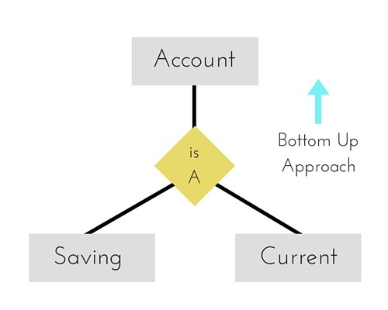
For example, Saving and Current account types entities can be generalised and an entity with name Account can be created, which covers both.

Specialization
Specialization is opposite to Generalization. It is a top-down approach in which one higher level entity can be broken down into two lower level entity. In specialization, a higher level entity may not have any lower-level entity sets, it's possible.
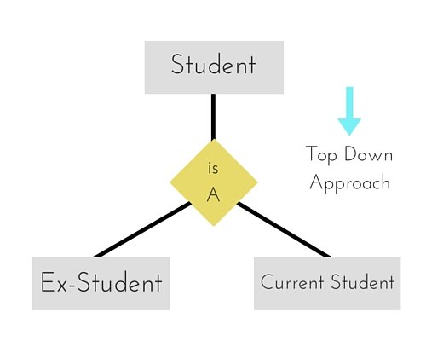

Aggregation
Aggregation is a process when relation between two entities is treated as a single entity.
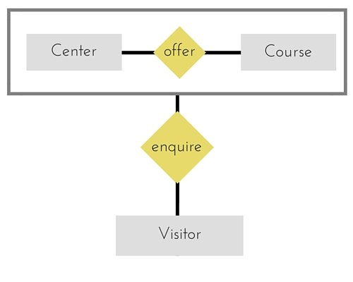
In the diagram above, the relationship between Center and Course together, is acting as an Entity, which is in relationship with another entity Visitor. Now in real world, if a Visitor or a Student visits a Coaching Center, he/she will never enquire about the center only or just about the course, rather he/she will ask enquire about both.

Codd's Rule for Relational DBMS
E.F Codd was a Computer Scientist who invented the Relational model for Database management. Based on relational model, the Relational database was created. Codd proposed 13 rules popularly known as Codd's 12 rules to test DBMS's concept against his relational model. Codd's rule actually define what quality a DBMS requires in order to become a Relational Database Management System(RDBMS). Till now, there is hardly any commercial product that follows all the 13 Codd's rules. Even Oracle follows only eight and half (8.5) out of 13. The Codd's 12 rules are as follows.

Rule zero
This rule states that for a system to qualify as an RDBMS, it must be able to manage database entirely through the relational capabilities.

Rule 1: Information rule
All information (including metadata) is to be represented as stored data in cells of tables. The rows and columns have to be strictly unordered.

Rule 2: Guaranted Access
Each unique piece of data (atomic value) should be accessible by : Table Name + Primary Key(Row) + Attribute(column).
NOTE: Ability to directly access via POINTER is a violation of this rule.

Rule 3: Systematic treatment of NULL
Null has several meanings, it can mean missing data, not applicable or no value. It should be handled consistently. Also, Primary key must not be null, ever. Expression on NULL must give null.

Rule 4: Active Online Catalog
Database dictionary(Catalog) is the structure description of the complete Database and it must be stored online. The Catalog must be governed by same rules as rest of the database. The same query language should be used on catalog as used to query database.

Rule 5: Powerful and Well-Structured Language
One well-structured language must be there to provide all manners of access to the data stored in the database. Example: SQL, etc. If the database allows access to the data without the use of this language, then that is a violation.

Rule 6: View Updation Rule
All the view that are theoretically updatable should be updatable by the system as well.

Rule 7: Relational Level Operation
There must be Insert, Delete, Update operations at each level of relations. Set operation like Union, Intersection and minus should also be supported.

Rule 8: Physical Data Independence
The physical storage of data should not matter to the system. If say, some file supporting table is renamed or moved from one disk to another, it should not affect the application.

Rule 9: Logical Data Independence
If there is change in the logical structure (table structures) of the database, the user view of data should not change. Say, if a table is split into two tables, a new view should give result as the join of the two tables. This rule is most difficult to satisfy.

Rule 10: Integrity Independence
The database should be able to enforce its own integrity rather than using other programs. Key and Check constraints, trigger etc., should be stored in Data Dictionary. This also make RDBMS independent of front-end.

Rule 11: Distribution Independence
A database should work properly regardless of its distribution across a network. Even if a database is geographically distributed, with data stored in pieces, the end user should get an impression that it is stored at the same place. This lays the foundation of distributed database.

Rule 12: Nonsubversion Rule
If low level access is allowed to a system, it should not be able to subvert or bypass integrity rules to change the data. This can be achieved by some sort of looking or encryption.

